COMPANY PROFILE
TEAMS

AN OPERATIONS-FOCUSED EXECUTIVE MANAGEMENT TEAM
The Executive Team plays a central role in leading the company’s projects:
- It determines and monitors actions to be carried out in the business;
- It oversees operations;
- It coordinates approaches to cross-functional issues and projects;
- It contributes to improving relationships with academics and industrials;
- It anticipates and prepares for organizational and strategic developments for the Company.
These highly experienced executives act as a team in charge of the implementation of GM Bamboo Eco-City’s’ strategy, ensuring that plans are coordinated and executed throughout the Company.

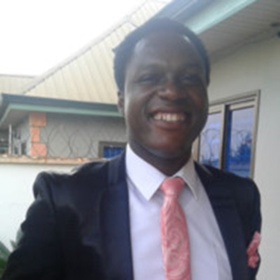 | 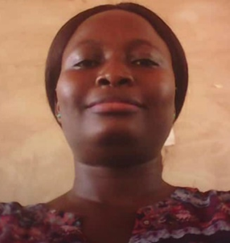 | 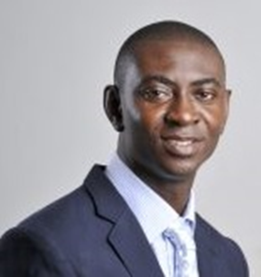
Engr. Samuel Kwaku Worwui  Founder & Chief Executive Officer  Engr. Samuel Kwaku Worwui, is a Green Building Expert; Fellow of IET, Ghana and an experienced Building Construction Engineer; IFC EDGE Auditor; IFC EDGE Expert, with twenty (20) years of progressive working experience in project conception, design and supervision in the Architectural, Engineering & Construction industry. Samuel has an edge to develop an innovative building construction composite material to lower the cost of construction. | Mrs. Favour Mawuwoe Worwui  Director of Marketing & Administration  Mrs. Favour Mawuwoe Worwui has fourteen (14) years’ experience in business administration and teaching with successful track record of paying attention to detail. She holds first degree in Management Studies (BMS) and Post Graduate Diploma in Education. | Ing. Dr. Emmanuel Appiah-Kubi  Director of Structural Engineering & Bamboo Expert  Ing. Dr. Emmanuel Appiah-Kubi, is a member of the “International Organization for Standardization” (ISO) Technical Committee on Bamboo & Rattan; a Research Scientist at CSIR-FORIG, Kumasi, Ghana and a Senior Lecturer at the Department of Construction and Wood Technology (University of Education, Winneba). He had his BSC, MPhil and PhD Degrees in Civil Engineering from the KNUST, Kumasi Ghana and has had a lot of international research stays at the Georg-August University of Goettingen, Germany and the Bern University of Applied Sciences, Biel, Switzerland.

 | 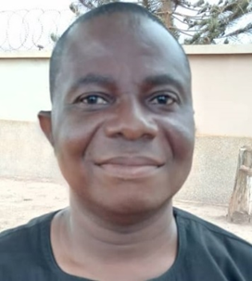 | 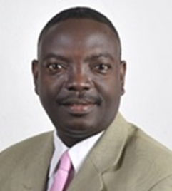
Ing. Dr. Anthony Andrews  Director Materials Technology & Engineering  Ing. Dr. Anthony Andrews, currently works at the Department of Materials Engineering, Kwame Nkrumah University of Science and Technology. He does research in Ceramic processing, focusing on development of both traditional and advanced ceramic materials including refractories. Current projects focus on lithomargic clay utilization and surface modification | Michael Vandyke  Director of Finance  Michael Vandyke is a business systems analyst and management consultant with SCG Associates, accredited distributors of Pastel Accounting software in Ghana. He has over 5-years’ experience consulting on private sector projects and over 17 years of progressive accounting experience. He has extensive experience in systems analysis and design, development planning, monitoring and evaluating systems, computerization of financial management systems. | Dr. Edward Yeboah  Soils & Biochar Technical Director  Dr. Edward Yeboah is a Principal Research Scientist and Deputy Director of the Council for Scientific and Industrial Research-Soil Research Institute, Kumasi, Ghana. Dr Yeboah is a Member of the International Biochar Initiative and a Steering Committee Member of African Biochar Partnership as well a Steering Committee member of the SIANI African Biochar Expert Group. Dr. Yeboah is the President of the International Foundation for Science-Ghana Alumni (IFS-Alumni, Ghana). He obtained his PhD in Soil Science, and has been working at CSIR-Soil Research Institute since 1998. In 2005, he spent six months working with Prof Johannes Lehmann Lab Group in Cornell University, Ithaca, New York. In 2006, he obtained the prestigious Rothamsted Research African Fellowship to become a Visiting Scientist at Rothamsted Research, UK.

George Wilson
Director of Operations

THE BOARD OF DIRECTORS
The Board of Directors’ task is to determine the operating priorities of the Company and ensure they are implemented. Its members have strong complementary expertise in industry, research and finance and high-level international experience.
Pastor Ernestina Hawkson
BOARD CHAIRPERSON

Engr. Samuel Kwaku Worwui  Founder & Chief Executive Officer | Ing. Dr. Emmanuel Appiah-Kubi  Director of Structural Engineering & Bamboo Expert | Ing. Dr. Anthony Andrews  Director Materials Technology & Engineering

Dr. Edward Yeboah  Soils & Biochar Technical Director | Christabel Hawkson  Secretary

THE ADVISORY COUNCIL
The Advisory Council is a consultative administrative Council that was formed to assist the Executive Manage Team with all Administrative issues, by providing advice, suggestions and recommendations.

The Mentorship and Investment Promotion COUNCIL
The Mentorship and Investment Promotion Board was formed provide mentorship and investment promotion for GOOD MORNING BAMBOO in the areas of investment promotion, entrepreneurship, Tax exemptions and obligations, Climate Change mitigation and adaptation; housing deficit and unemployment, especially among youths and women.

AUDIT COMMITTEE
GM Bamboo Eco-City’s Board of Directors decided to create an independent Audit Committee with its own specific areas of responsibility as follows.

the process for producing financial information;
the efficiency and effectiveness of internal control and risk management systems;
the statutory audit of the annual and consolidated financial statements by the statutory auditors; and
the independence of the statutory auditors.
In addition, the Committee will issue a recommendation on statutory auditors. It will reports regularly to the Board of Directors on its tasks and informs the Board immediately of any issues or concerns.

The Committee can at any time discuss any significant financial or accounting question related to its areas of responsibility and provide its opinions or recommendations to the Board.

The Board may also entrust the Committee with any other assignments it deems appropriate. The Board will establish the Committee’s composition. Nevertheless, the Committee must be made up exclusively of Board members who do not have executive management responsibilities in the Company. And these directors must have specific financial or accounting expertise.

